MODELLING THE DIGESTIVE SYSTEM

WHAT YOU NEED TO MAKE A DIGESTIVE SYSTEM MODEL

Potato masher – or something else to crush the food with.

2 x Bowl

Funnel

1 small banana or piece of bread

1 plain biscuit

30ml water

30ml orange juice

Medium size ziploc bag – stomach

Scissors

I leg from a pair of tights – small intestine

Tray or plate

DIGESTION MODEL INSTRUCTIONS

1. Place the biscuit and banana into a bowl and gently crush with a potato masher.
2. Pour the crushed food into an empty ziploc bag and add the water.
3. Pour the orange juice into the bag. Make sure there is no air in the bag and seal it.
4. Squeeze the bag for about a minute crushing up the biscuits and banana further.
5. Once the stomach contents feel like a thick liquid, cut a small hole in the one corner and carefully squeeze into the open leg of the tights.
6. Hold the tights over the tray or a bowl and gently squeeze the liquid out. The liquid on the tray represents the nutrients the body absorbs and uses.
7. Keep squeezing until no more liquid comes out.
8. The food left behind in the tights represents waste products that cannot be absorbed.
9. Cut a hole in the bottom of the tights and squeeze the contents into the jar. This is the poo!

QUESTIONS

1. Identify the equipment use to represent the following components of the digestive system
   1. Mouth = ___________________
   2. Teeth = ___________________
   3. Ziploc bag = ___________________
   4. Water = ___________________
   5. Orange Juice = ___________________
   6. Tights = ___________________
2. Why did you have to mix the food in the stomach? What process did this replicate?

____________________________________________________________________________________________________________________________________________________________________________________________________________________________________________________________________________________________________________

1. 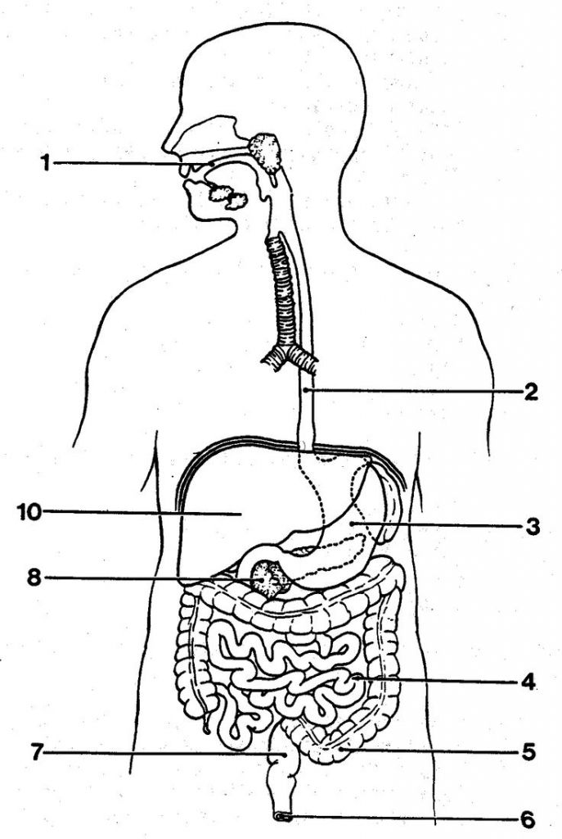Label the following diagram of the digestive system. Write the function of each part in the table.

|  |  |
| --- | --- |
| Name | Function |
| 1 |  |
| 2 |  |
| 3 |  |
| 4 |  |
| 5 |  |
| 6 |  |
| 7 |  |
| 8 |  |
| 10 |  |